**EPI/Lifestyle 2025 Scientific Sessions; 03/06/2025 – 03/09/2025; New Orleans, LA**

**Joint Accreditation Statements**

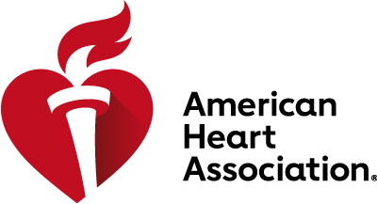

In support of improving patient care, this activity has been planned and implemented by the American Heart Association. The American Heart Association is jointly accredited by the Accreditation Council for Continuing Medical Education (ACCME), the Accreditation Council for Pharmacy Education (ACPE), and the American Nurses Credentialing Center (ANCC), to provide continuing education for the healthcare team.

**AMA Credit Designation Statement - Physicians**

The American Heart Association designates this live activity for a maximum of 23.00 *AMA PRA Category 1 Credits™*. Physicians should claim only the credit commensurate with the extent of their participation in the activity.

**AAPA Credit Acceptance Statement – Physician Associates**

AAPA accepts certificates of participation for educational activities certified for *AMA PRA Category 1 Credit™* from organizations accredited by ACCME or a recognized state medical society. Physician associates may receive a maximum of 23.00 hours of Category I credit for completing this program.

**AANP Credit Acceptance Statement – Nurse Practitioners**

American Academy of Nurse Practitioners (AANP) accepts *AMA PRA Category 1 Credit*TM from organizations accredited by the ACCME.

*\*\*AMA Credit must be claimed within 6 months of attendance. Credit will no longer be available to claim after September 9, 2025.*

**ANCC Credit Designation Statement - Nurses**

The maximum number of hours awarded for this CE activity is 23.00contact hours.

*\*\*ANCC Credit must be claimed within 6 months of attendance. CE credit will no longer be available to claim after September 9, 2025.*

**ACPE Credit Designation Statement – Pharmacists**

ACPE Credit: 23.00 Contact Hours. Universal Program Number: JA0000134-0000-25-003-L04-P

*\*\*ACPE Credit must be claimed within 30 days of participation. ACPE credit will no longer be available to claim after April 9, 2025.*

**Disclosure Policy**

All persons in a position to control educational content of a CE activity provided by the American Heart Association must disclose to the audience all financial relationships with ineligible companies whose primary business is producing, marketing, selling, re-selling, or distributing healthcare products used by or on patients. The presence or absence of all financial relationships will be disclosed to the audience in activity materials. All unlabeled/unapproved uses of drugs or devices discussed will also be disclosed to the audience. All relevant financial relationships have been mitigated prior to the commencement of the activity.