PAD Swiss Cheese Post
Creative | Copy
PAD symptoms  Get screened for Peripheral Artery Disease  One or more of these symptoms put you at risk:  A family history of PAD  Diabetes  Chronic kidney disease  High blood pressure  High cholesterol  Smoking  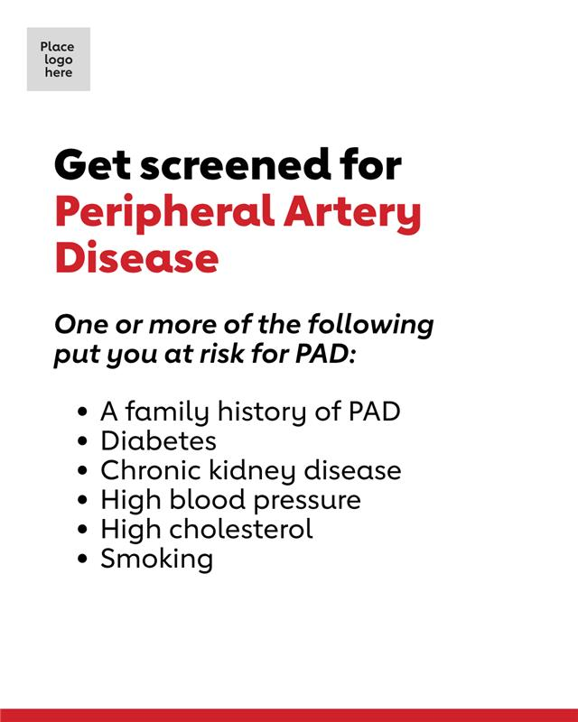 | Peripheral artery disease, or PAD, is painful or uncomfortable muscle cramping in the hips, thighs or calves when walking, climbing stairs or exercising. Early diagnosis and treatment can prevent serious consequences, including amputation, heart attack or stroke. Join us for [name of event], [time, date, address], to learn more about your risk for PAD. RSVP at [link].

